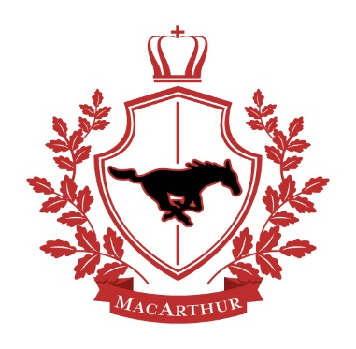

MacArthur Intermediate School

2018 – 2019 Supply List

Elementary ART

1 – Paper towel roll

2 – Baby wipes

Crayons

Markers

1 – Glue bottle

Pencils

1 – Eraser

Watercolor set

Plastic container for all Art supplies (not larger than a shoebox)

Apron (optional)

\*Please write student’s name on all supplies. These supplies will be kept in the Art Room.\*