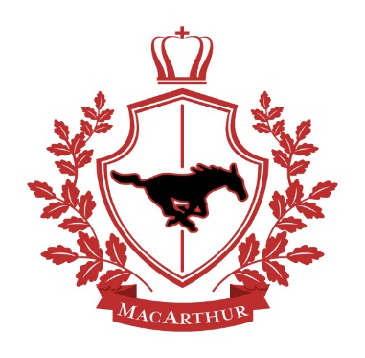

MacArthur Intermediate School

2018 – 2019 Supply List

Middle School SCIENCE and ART

**SCIENCE**

College ruled loose leaf paper

Pack of pencils (mechanical or wood)

Pens (black or blue)

Colored pencils

1 – Box of tissue

1 – Folder (to keep loose leaf paper and returned assignments)

1 – Hand sanitizer

Notebook

**ART**

2 – Paper towel rolls

2 – Baby wipes

1 – Bottled hand soap

1 – Hand sanitizer

Colored pencils

Sketchbook

Markers

Glue bottle

Scissors

Pencils

Eraser

Watercolor set

Plastic container for all art supplies (not larger than a shoebox)

Apron (optional)

*Please write student’s name on all supplies. These supplies will be kept in the Art Room.*