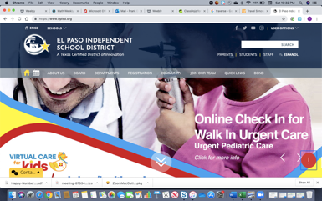
The first thing students MUST do is log onto Schoology. The easiest steps to do this are as follows:
1
1.Go to www.episd.org

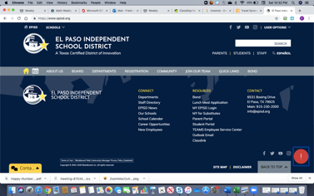
2. Scroll to the very bottom and under the resource
2
section, click on: CLASSLINK

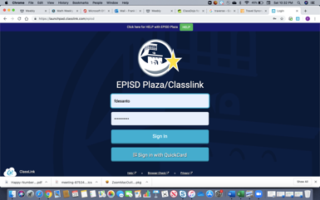
3. Have the student put their AR username and password
3
into CLASSLINK
- cadwy1234 (example) password
- 19930614 (Year of student birth/month/day)-username
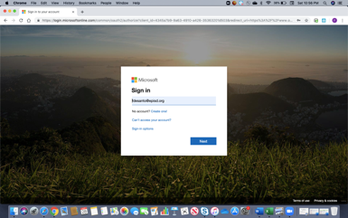

4. Sign in with AR Username@episd.org and then password
4
4

Cadwy1234@episd.org (example) – Click Next

19930614 (Year of student birth/month/day) –Sign In

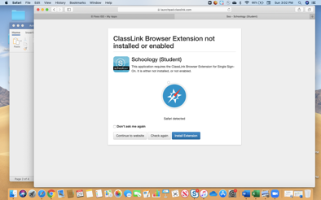
5. In order to enable Classlink, click on Continue
5
4
to Website

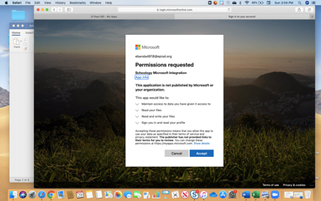
6. Permission Requested may be required at this point
65

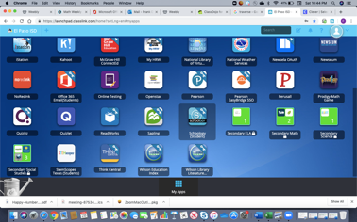
7. Once in CLASSLINK, all the apps will be available for
75
student use (Istation, MyON and Schoology, Office 365.)
Now Click on the Schoology App.

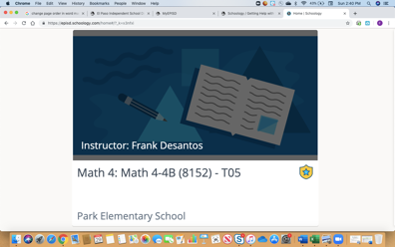
8-You are then logged into Schoology. From the courses
tab, you may click on the appropriate math section
85
for your child.

To access individual student emails, the student must do the following:

-Log onto WWW.office.com

-Click Sign In

-Click on Work or School account

-Sign in with AR Username@episd.org and then password

Cadwy1234@episd.org (example) – Click Next

19930614 (Year of student birth/month/day) – Click Sign In

-Stay Signed In screen appears – Click Yes

-You are now in Office 365 main page.

-Click on Outlook to enable EMAIL.

-Your student can email me completed emails from this section.

-Your student will now have an email address similar to the following example:

Cadwy1234@episdorg.onmicrosoft.com

