March | 2022

Core Value: Cooperation
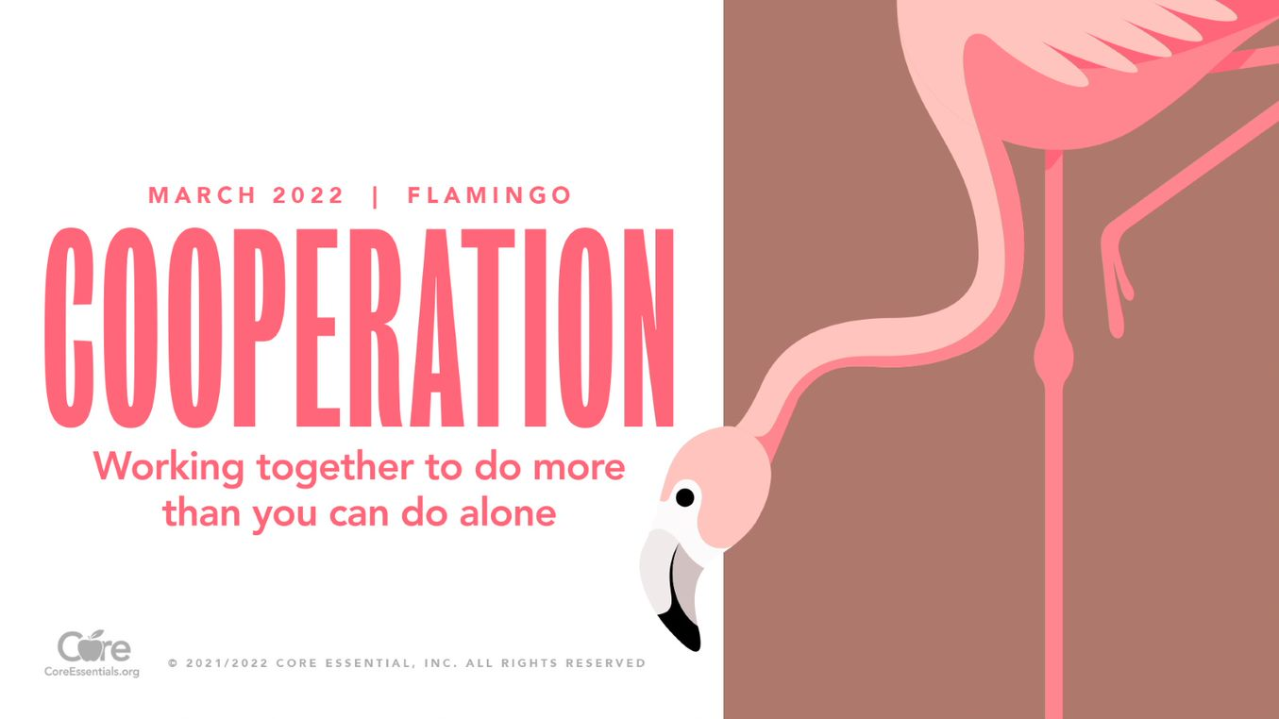
Sunday | Monday | Tuesday | Wednesday | Thursday | Friday | Saturday
 |  | 1 | 2 | 3 | 4 | 5
Women’s History Month | Read Across America ----------- | Superintendent visit at 12:45  Wear a shirt others can read | YWA visit for 5th grade girls at 8:30  Wear Green! | Wear fun or mismatched socks! | Wear a college t-shirt
6 | 7 | 8 | 9 | 10 | 11 | 12
 | Staff Development  No School Students | International Women’s Day  Intersession  No School | Intersession  No School | Intersession  No School | Intersession  No School
13 | 14 | 15 | 16 | 17 | 18 | 19
Daylight Savings Time | Intersession  No School | Intersession  No School | Intersession  No School | St. Patrick’s Day  Intersession  No School | Intersession  No School
20 | 21 | 22 | 23 | 24 | 25 | 26
27 | 28 | 29 | 30 | 31
Cooperation: Working together to do more than you can do alone.

