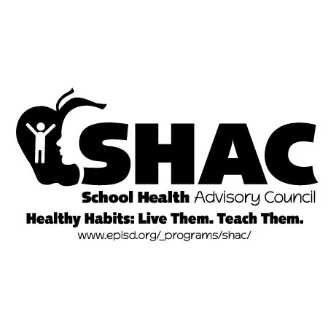

School Health Advisory Committee

March 24, 2022

5:00 PM

EPISD PDC – 6500K Boeing Dr.

**5:00 Call to Order**-

Welcome

**Approval of minutes from January 20, 2022 meeting**

**Special Presentation:** New HS Health Textbook review (unofficial review)

**Committee Development**

Priorities Planning by Committees

**Human Sexuality**

SHAC Approved Health curriculum

**Wellness**

Wellness Policy Accountability

**Physical Activity and Fitness**

Guidelines on MVPA

Offer staff Free or low cost PA/Fitness programs

**Nutrition**

Alternatives to food rewards

Future Meeting Dates

May 19, 2022

Any other unfinished business

Next Meeting: May 19, 2022

Adjourn

Javier Carrasco- Recording